UNITED STATES
SECURITIES AND EXCHANGE COMMISSION
WASHINGTON, D.C. 20549

FORM 6-K

REPORT OF FOREIGN PRIVATE ISSUER
PURSUANT TO RULE 13a-16 OR 15d-16 OF THE
SECURITIES EXCHANGE ACT OF 1934

For the month of August 2026

Commission File Number 001-41776

SOLOWIN HOLDINGS
(Translation of registrant’s name into English)

Room 1910-1912A, Tower 3, China Hong Kong City
33 Canton Road, Tsim Sha Tsui, Kowloon
Hong Kong
(Address of principal executive offices)

Indicate by check mark whether the registrant files or will file annual reports under cover of Form 20-F or Form 40-F:

Form 20-F ☒ Form 40-F ☐

SIGNATURES

Pursuant to the requirements of the Securities Exchange Act of 1934, the registrant has duly caused this report to be signed on its behalf by the undersigned, thereunto duly authorized.

Date: August 21, 2026 | SOLOWIN HOLDINGS
 | By: | /s/ Ling Ngai Lok
 |  | Ling Ngai Lok
 |  | Chief Executive Officer

1

EXHIBIT INDEX

Exhibit No. |  | Description
99.1 |  | Press Release dated August 21, 2026.
99.2 |  | Investor Presentation

2

Exhibit 99.1

SOLOWIN HOLDINGS (NASDAQ: AXG) Celebrates 10-Year Anniversary, Forging Compliance-First Innovation for AI + Stablecoin Ecosystem

Hong Kong, August 21, 2026 (GLOBE NEWSWIRE) — SOLOWIN HOLDINGS (Nasdaq: AXG) (together with its subsidiaries, “AXG” or the “Company”), a leading financial technology firm bridging traditional and digital assets, today announced the celebration of its tenth anniversary, marking a decade of compliance-led innovative finance.

Tracing its operating history to 2016, when it began in traditional finance, AXG has evolved into a fully compliant dual-token digital economy platform. Guided by its mission, “Mobilizing Tokens 24/7,” the Company currently operates two core business pillars: Digital Asset Tokens, centered on stablecoins and tokenized real-world assets, and AI Tokens, which brings artificial intelligence (“AI”) infrastructure, agent governance and intelligent financial services into the token economy.

AXG’s evolution has been defined by a disciplined approach to innovation and regulation compliance. The Company began operations in Hong Kong in 2016 and subsequently obtained license from the Hong Kong Securities and Futures Commission for regulated financial activities. The Company became listed on Nasdaq in 2023 and completed its virtual-asset business upgrade in Hong Kong in 2024. In 2025, AXG further expanded its capabilities in tokenization and AI through the acquisition of AlloyX Limited, a next-generation stablecoin infrastructure focused on tokenized money-market funds and cross-border payments. In 2026, the Company further advanced its tokenization and AI infrastructure initiatives and, through AX Coin Bahrain B.S.C. (c), a regulated stablecoin issuer subsidiary of AXG, secured a full stablecoin issuance license from the Central Bank of Bahrain and obtained the world’s first Sharia-compliant stablecoin certification.

AXG’s integrated ecosystem is designed to connect institutional finance with the digital asset and AI economies through an end-to-end, compliance-first operating model covering the complete token lifecycle, from stablecoin issuance, treasury management and cross-border payments to tokenization, AI-agent governance and AI-enabled payment execution. This ecosystem currently is comprised of the following platforms—AXCOIN supports regulated stablecoin issuance and agentic payments; AXONE provides global stablecoin treasury management; FERION enables real-world asset tokenization; KOVAR delivers AI infrastructure, agent identity and compliance capabilities, and a global AI Token Router; AgentX provides AI-driven wealth management; and Solomon JFZ serves as AXG’s Hong Kong virtual-asset-upgraded investment banking platform.

Mr. Peter Lok, Chairman and Chief Executive Officer of the Company, said: “Ten years ago, we began with a clear conviction: the future of finance would require both technological innovation and trusted regulatory foundations, Today, AXG is building on that foundation as an innovative and regulated platform. Our mission, ‘Mobilizing Tokens 24/7,’ reflects our focus on making regulated digital value more useful, programmable and accessible across borders, institutions and intelligent systems.”

Dr. Thomas Zhu, a director of the Company, commented “Compliance has been central to every stage of our development. Our progress across Hong Kong and Bahrain, including the full stablecoin issuance license in Bahrain and the world’s first Sharia-compliant stablecoin certification, demonstrates how responsible innovation can create a foundation for global adoption. In our next chapter, we will continue to integrate stablecoins, tokenization and AI agents into practical, institutional-grade financial infrastructure.”

About SOLOWIN HOLDINGS

SOLOWIN HOLDINGS (Nasdaq: AXG) is a leading global regulated fintech company. Established in 2016, AXG combines blockchain and artificial intelligence technologies to operate a fully compliant dual-token digital economy super platform.

Guided by the mission “Mobilizing Tokens 24/7,” the Company operates two core business pillars: Digital Asset Tokens and AI Tokens. Its offerings span stablecoin issuance and payments, asset tokenization, securities trading and asset management, as well as AI-powered services including cloud infrastructure, Know-Your-Agent verification, and token router.

Through its integrated ecosystem, including AX COIN, AX ONE, FERION, Solomon JFZ , AgentX, and KOVAR, AXG empowers global institutions and investors to capitalize on the rapid growth of the dual-token economy.

For more information, visit www.alloyx.com and follow us on LinkedIn at AXG (Solowin Holdings).

Forward-Looking Statements

Certain statements in this announcement are forward-looking statements, within the meaning of Section 27A of the Securities Act of 1933, as amended, and Section 21E of the Securities Exchange Act of 1934, as amended. These forward-looking statements involve known and unknown risks and uncertainties and are based on the Company’s current expectations and projections about future events that the Company believes may affect its financial condition, results of operations, business strategy and financial needs. The Company has attempted to identify these forward-looking statements by words or phrases such as “may,” “will,” “expect,” “anticipate,” “aim,” “estimate,” “intend,” “plan,” “believe,” “is/are likely to,” “potential,” “continue” or other similar expressions. The Company undertakes no obligation to update or revise publicly any forward-looking statements to reflect subsequent occurring events or circumstances, or changes in its expectations that arise after the date hereof, except as may be required by law. These statements are subject to uncertainties and risks including, but not limited to, the uncertainties related to market conditions and other factors discussed in the Company’s filings with the U.S. Securities and Exchange Commission (the “SEC”) including the “Risk Factors” section of the Company’s most recent Annual Report on Form 20-F as well as in its other reports filed or furnished from time to time with the SEC. Although the Company believes that the expectations expressed in these forward-looking statements are reasonable, it cannot assure you that such expectations will turn out to be correct, and the Company cautions investors that actual results may differ materially from the anticipated results and encourages investors to review other factors that may affect its future results in the Company’s filings with the SEC, which are available for review at www.sec.gov.

For investor and media inquiries, please contact:

SOLOWIN HOLDINGS
Investor Relations Department
Email: ir@solowin.io

Ascent Investor Relations LLC
Tina Xiao
Phone: +1-646-932-7242
Email: investors@ascent-ir.com

Exhibit 99.2

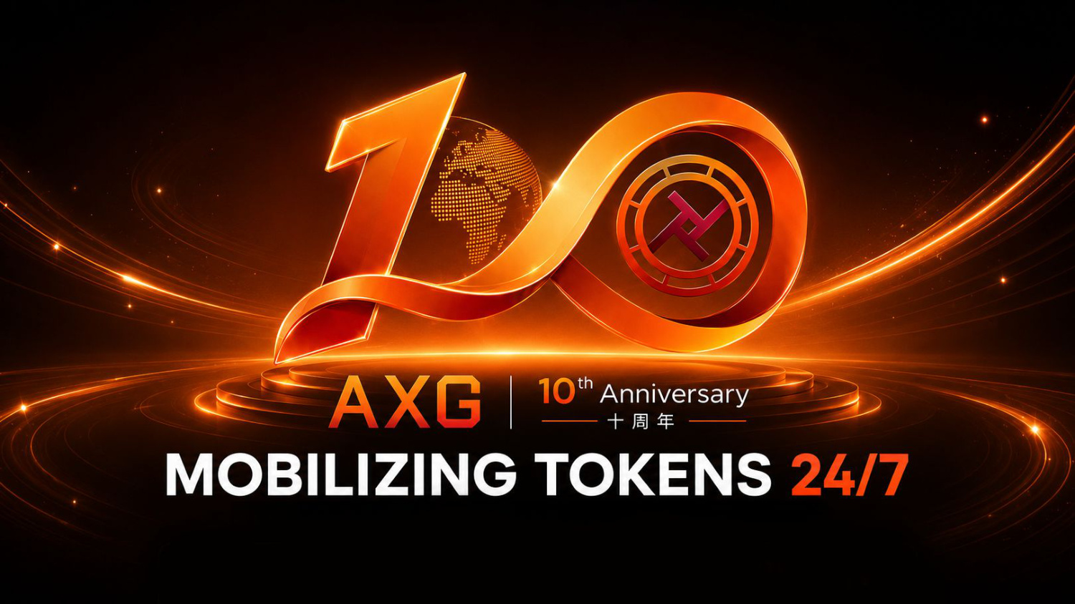

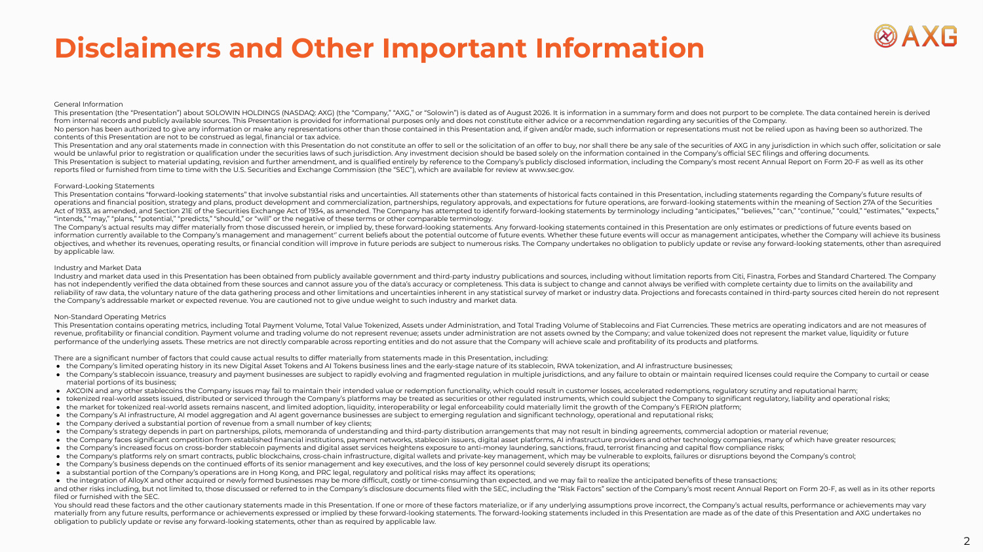
Disclaimers and Other Important Information General Information This presentation (the "Presentation") about SOLOWIN HOLDINGS (NASDAQ: AXG) (the "Company," "AXG," or "Solowin") is dated as of August 2026. It is information in a summary form and does not purport to be complete. The data contained herein is derived from internal records and publicly available sources. This Presentation is provided for informational purposes only and does not constitute either advice or a recommendation regarding any securities of the Company. No person has been authorized to give any information or make any representations other than those contained in this Presentation and, if given and/or made, such information or representations must not be relied upon as having been so authorized. The contents of this Presentation are not to be construed as legal, financial or tax advice. This Presentation and any oral statements made in connection with this Presentation do not constitute an offer to sell or the solicitation of an offer to buy, nor shall there be any sale of the securities of AXG in any jurisdiction in which such offer, solicitation or sale would be unlawful prior to registration or qualification under the securities laws of such jurisdiction. Any investment decision should be based solely on the information contained in the Company's official SEC filings and offering documents. This Presentation is subject to material updating, revision and further amendment, and is qualified entirely by reference to the Company's publicly disclosed information, including the Company's most recent Annual Report on Form 20-F as well as its other reports filed or furnished from time to time with the U.S. Securities and Exchange Commission (the "SEC"), which are available for review at www.sec.gov. Forward-Looking Statements This Presentation contains "forward-looking statements" that involve substantial risks and uncertainties. All statements other than statements of historical facts contained in this Presentation, including statements regarding the Company's future results of operations and financial position, strategy and plans, product development and commercialization, partnerships, regulatory approvals, and expectations for future operations, are forward-looking statements within the meaning of Section 27A of the Securities Act of 1933, as amended, and Section 21E of the Securities Exchange Act of 1934, as amended. The Company has attempted to identify forward-looking statements by terminology including "anticipates," "believes," "can," "continue," "could," "estimates," "expects," "intends," "may," "plans," "potential," "predicts," "should," or "will" or the negative of these terms or other comparable terminology. The Company's actual results may differ materially from those discussed herein, or implied by, these forward-looking statements. Any forward-looking statements contained in this Presentation are only estimates or predictions of future events based on information currently available to the Company's management and management'' current beliefs about the potential outcome of future events. Whether these future events will occur as management anticipates, whether the Company will achieve its business objectives, and whether its revenues, operating results, or financial condition will improve in future periods are subject to numerous risks. The Company undertakes no obligation to publicly update or revise any forward-looking statements, other than as required by applicable law. Industry and Market Data Industry and market data used in this Presentation has been obtained from publicly available government and third-party industry publications and sources, including without limitation reports from Citi, Finastra, Forbes and Standard Chartered. The Company has not independently verified the data obtained from these sources and cannot assure you of the data's accuracy or completeness. This data is subject to change and cannot always be verified with complete certainty due to limits on the availability and reliability of raw data, the voluntary nature of the data gathering process and other limitations and uncertainties inherent in any statistical survey of market or industry data. Projections and forecasts contained in third-party sources cited herein do not represent the Company's addressable market or expected revenue. You are cautioned not to give undue weight to such industry and market data. Non-Standard Operating Metrics This Presentation contains operating metrics, including Total Payment Volume, Total Value Tokenized, Assets under Administration, and Total Trading Volume of Stablecoins and Fiat Currencies. These metrics are operating indicators and are not measures of revenue, profitability or financial condition. Payment volume and trading volume do not represent revenue; assets under administration are not assets owned by the Company; and value tokenized does not represent the market value, liquidity or future performance of the underlying assets. These metrics are not directly comparable across reporting entities and do not assure that the Company will achieve scale and profitability of its products and platforms. There are a significant number of factors that could cause actual results to differ materially from statements made in this Presentation, including: ● the Company's limited operating history in its new Digital Asset Tokens and AI Tokens business lines and the early-stage nature of its stablecoin, RWA tokenization, and AI infrastructure businesses; ● the Company's stablecoin issuance, treasury and payment businesses are subject to rapidly evolving and fragmented regulation in multiple jurisdictions, and any failure to obtain or maintain required licenses could require the Company to curtail or cease material portions of its business; ● AXCOIN and any other stablecoins the Company issues may fail to maintain their intended value or redemption functionality, which could result in customer losses, accelerated redemptions, regulatory scrutiny and reputational harm; ● tokenized real-world assets issued, distributed or serviced through the Company's platforms may be treated as securities or other regulated instruments, which could subject the Company to significant regulatory, liability and operational risks; ● the market for tokenized real-world assets remains nascent, and limited adoption, liquidity, interoperability or legal enforceability could materially limit the growth of the Company's FERION platform; ● the Company's AI infrastructure, AI model aggregation and AI agent governance businesses are subject to emerging regulation and significant technology, operational and reputational risks; ● the Company derived a substantial portion of revenue from a small number of key clients; ● the Company's strategy depends in part on partnerships, pilots, memoranda of understanding and third-party distribution arrangements that may not result in binding agreements, commercial adoption or material revenue; ● the Company faces significant competition from established financial institutions, payment networks, stablecoin issuers, digital asset platforms, AI infrastructure providers and other technology companies, many of which have greater resources; ● the Company's increased focus on cross-border stablecoin payments and digital asset services heightens exposure to anti-money laundering, sanctions, fraud, terrorist financing and capital flow compliance risks; ● the Company's platforms rely on smart contracts, public blockchains, cross-chain infrastructure, digital wallets and private-key management, which may be vulnerable to exploits, failures or disruptions beyond the Company's control; ● the Company's business depends on the continued efforts of its senior management and key executives, and the loss of key personnel could severely disrupt its operations; ● a substantial portion of the Company's operations are in Hong Kong, and PRC legal, regulatory and political risks may affect its operations; ● the integration of AlloyX and other acquired or newly formed businesses may be more difficult, costly or time-consuming than expected, and we may fail to realize the anticipated benefits of these transactions; and other risks including, but not limited to, those discussed or referred to in the Company's disclosure documents filed with the SEC, including the "Risk Factors" section of the Company's most recent Annual Report on Form 20-F, as well as in its other reports filed or furnished with the SEC. You should read these factors and the other cautionary statements made in this Presentation. If one or more of these factors materialize, or if any underlying assumptions prove incorrect, the Company's actual results, performance or achievements may vary materially from any future results, performance or achievements expressed or implied by these forward-looking statements. The forward-looking statements included in this Presentation are made as of the date of this Presentation and AXG undertakes no obligation to publicly update or revise any forward-looking statements, other than as required by applicable law. 2

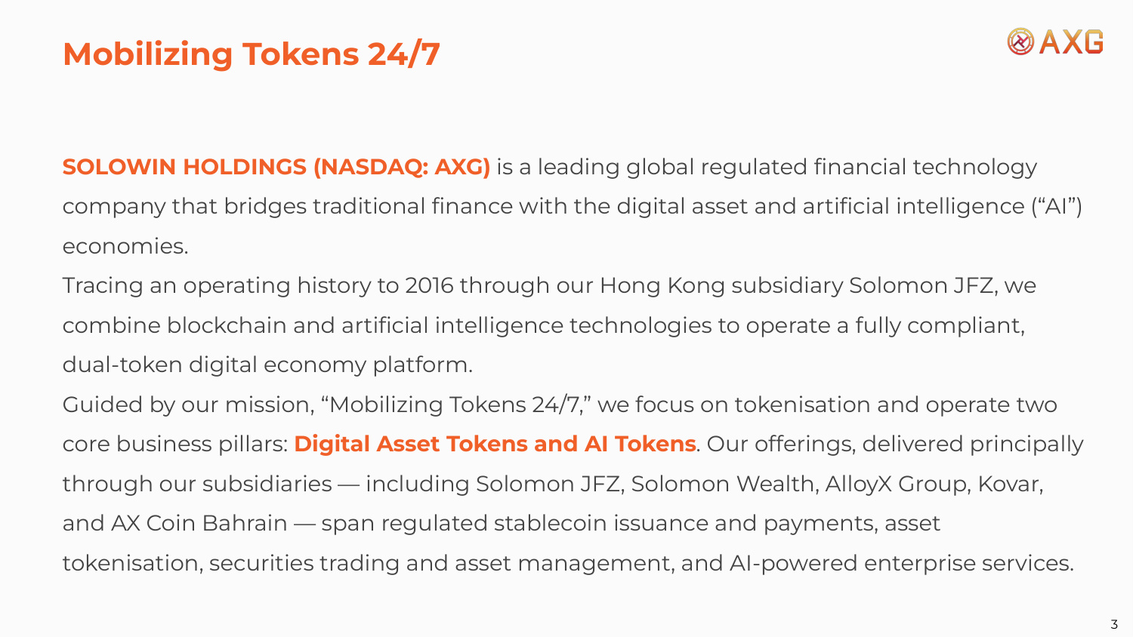
Mobilizing Tokens 24/7 SOLOWIN HOLDINGS (NASDAQ: AXG) is a leading global regulated financial technology company that bridges traditional finance with the digital asset and artificial intelligence ("AI") economies. Tracing an operating history to 2016 through our Hong Kong subsidiary Solomon JFZ, we combine blockchain and artificial intelligence technologies to operate a fully compliant, dual-token digital economy platform. Guided by our mission, "Mobilizing Tokens 24/7," we focus on tokenisation and operate two core business pillars: Digital Asset Tokens and AI Tokens. Our offerings, delivered principally through our subsidiaries — including Solomon JFZ, Solomon Wealth, AlloyX Group, Kovar, and AX Coin Bahrain — span regulated stablecoin issuance and payments, asset tokenisation, securities trading and asset management, and AI-powered enterprise services. 3

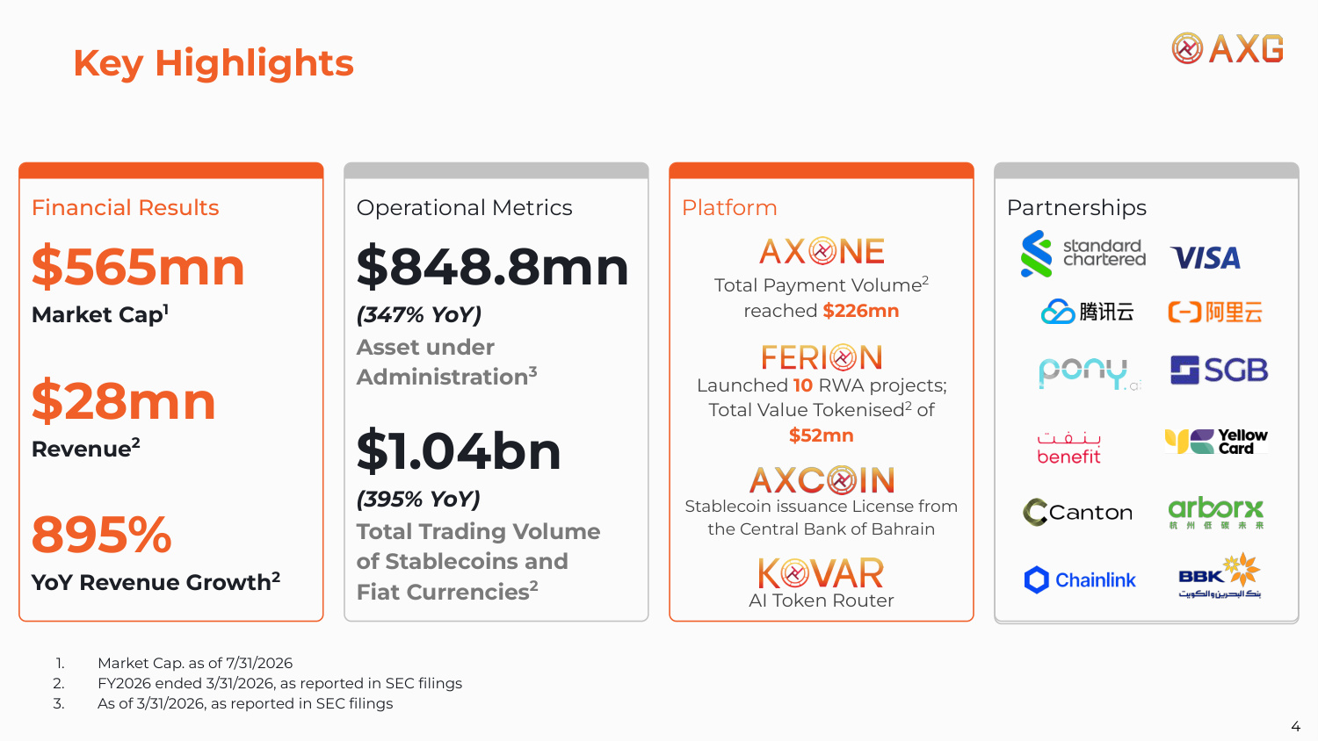
Financial Results Total Payment Volume2 reached $226mn 1. Market Cap. as of 7/31/2026 2. FY2026 ended 3/31/2026, as reported in SEC filings 3. As of 3/31/2026, as reported in SEC filings Launched 10 RWA projects; Total Value Tokenised2 of $52mn AI Token Router Stablecoin issuance License from the Central Bank of Bahrain Key Highlights $565mn Market Cap1 $28mn Revenue2 895% YoY Revenue Growth2 Operational Metrics $848.8mn (347% YoY) Asset under Administration3 $1.04bn (395% YoY) Total Trading Volume of Stablecoins and Fiat Currencies2 Platform Partnerships 4

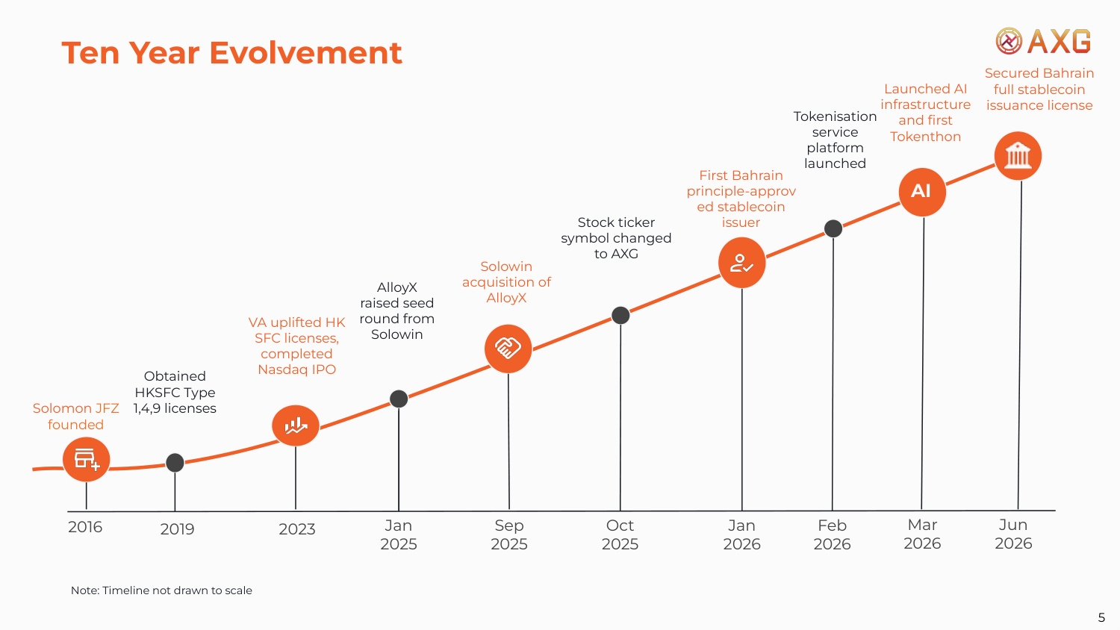
Solomon JFZ founded Note: Timeline not drawn to scale Launched AI infrastructure and first Tokenthon Jan 2025 Sep 2025 Oct 2025 Jan 2026 Feb 2026 Mar 2026 2023 2016 2019 Jun 2026 Secured Bahrain full stablecoin issuance license Obtained HKSFC Type 1,4,9 licenses VA uplifted HK SFC licenses, completed Nasdaq IPO AlloyX raised seed round from Solowin Solowin acquisition of AlloyX Stock ticker symbol changed to AXG First Bahrain principle-approv ed stablecoin issuer Tokenisation service platform launched Ten Year Evolvement 5 AI

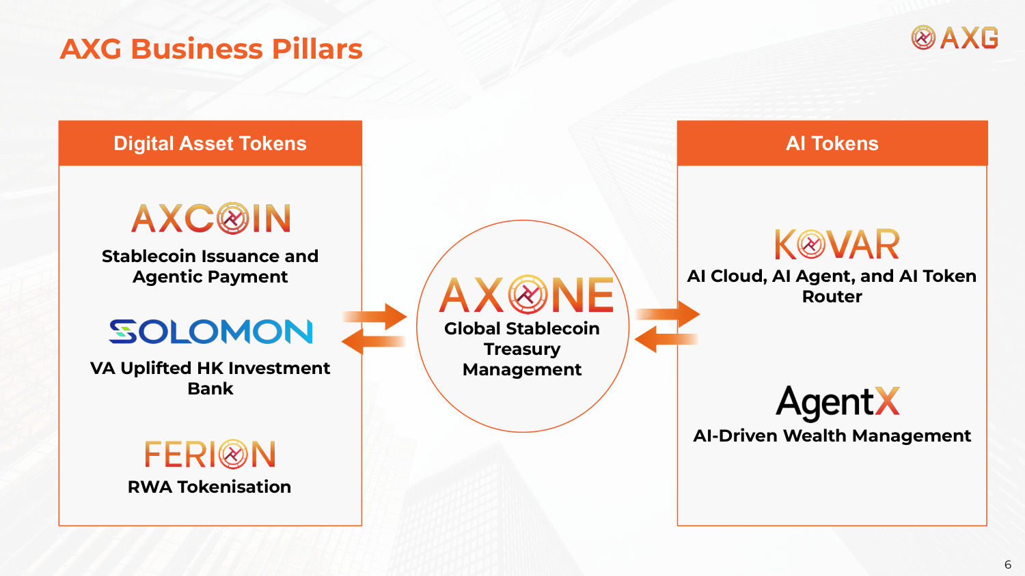
Digital Asset Tokens AI Tokens VA Uplifted HK Investment Bank Stablecoin Issuance and Agentic Payment AI Cloud, AI Agent, and AI Token Router RWA Tokenisation AI-Driven Wealth Management Global Stablecoin Treasury Management AXG Business Pillars 6

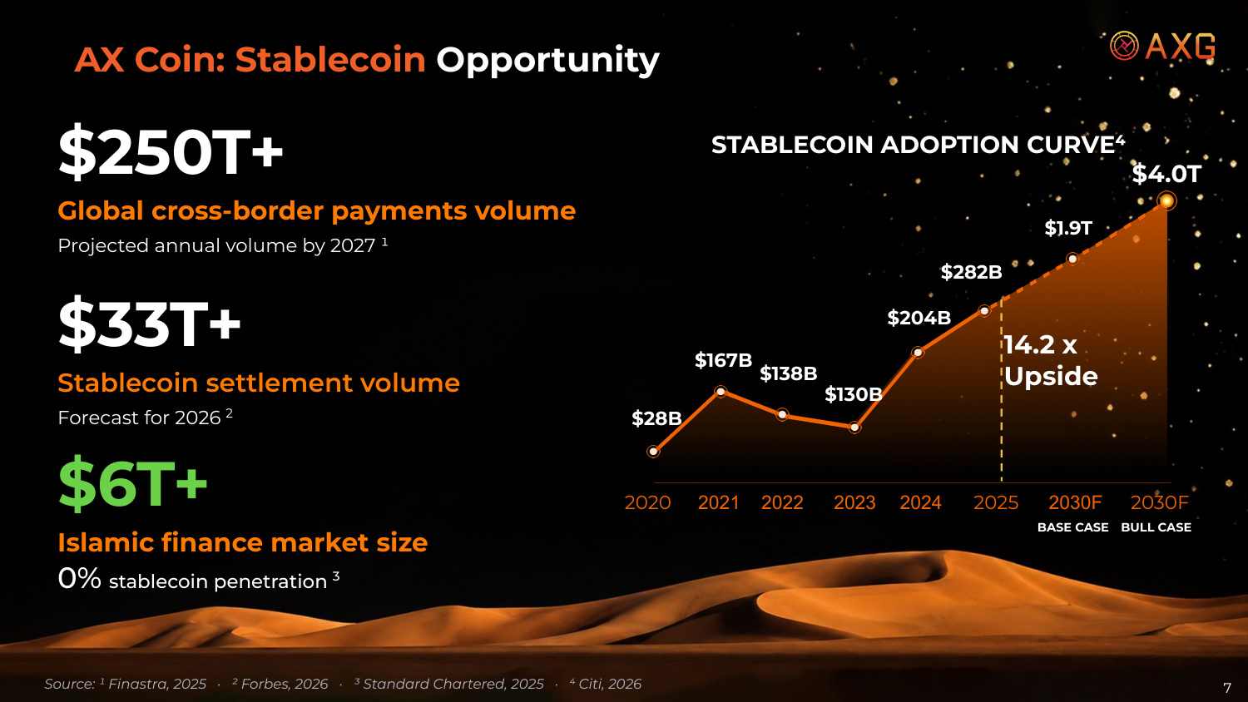
STABLECOIN ADOPTION CURVE⁴ 14.2 x Upside $28B $167B $138B $130B $204B $282B $1.9T $4.0T 2020 2021 2022 2023 2024 2025 2030F 2030F Source: ¹ Finastra, 2025 · ² Forbes, 2026 · ³ Standard Chartered, 2025 · ⁴ Citi, 2026 $250T+ Global cross-border payments volume Projected annual volume by 2027 ¹ $33T+ Stablecoin settlement volume Forecast for 2026 2 $6T+ Islamic finance market size 0% stablecoin penetration 3 BASE CASE BULL CASE 7 AX Coin: Stablecoin Opportunity

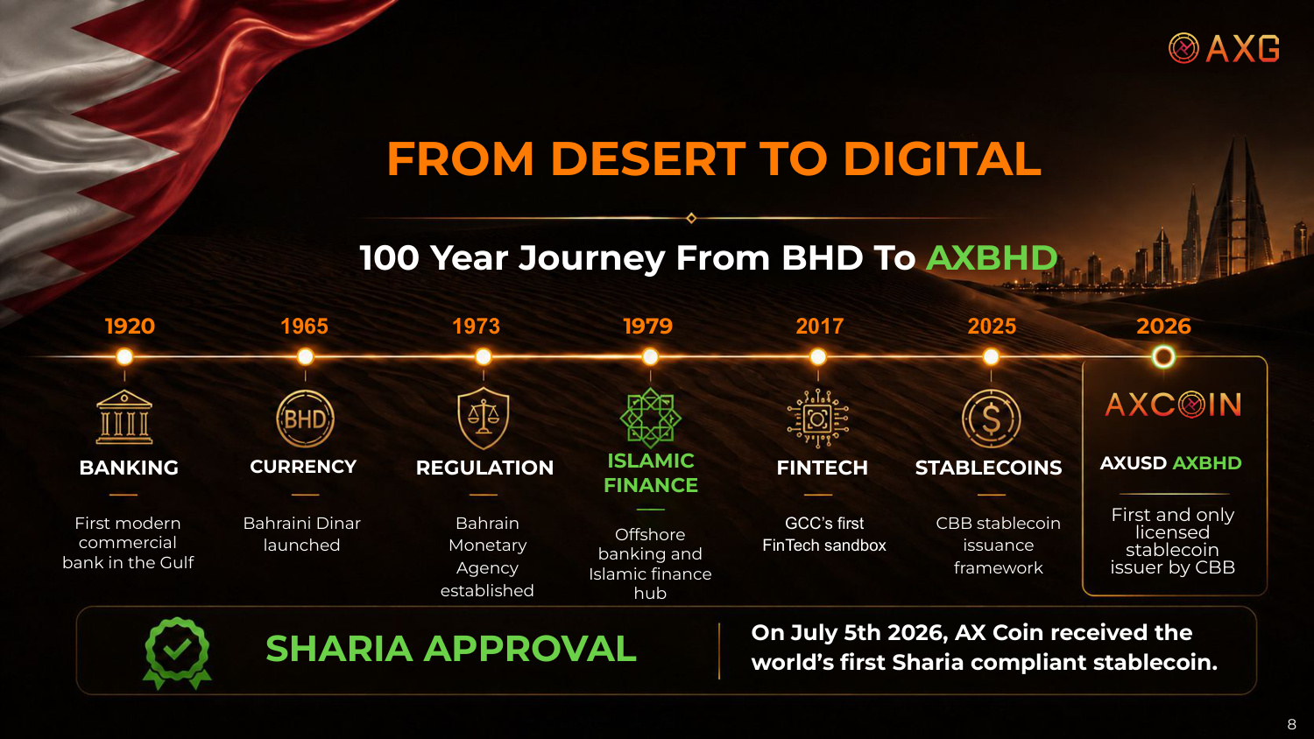
SHARIA APPROVAL On July 5th 2026, AX Coin received the world's first Sharia compliant stablecoin. Offshore banking and Islamic finance hub CBB stablecoin issuance framework BANKING First modern commercial bank in the Gulf GCC's first FinTech sandbox Bahraini Dinar launched Bahrain Monetary Agency established First and only licensed stablecoin issuer by CBB 100 Year Journey From BHD To AXBHD 1920 CURRENCY REGULATION ISLAMIC FINANCE FINTECH STABLECOINS AXUSD AXBHD 1965 1973 1979 2017 2025 FROM DESERT TO DIGITAL 2026 8

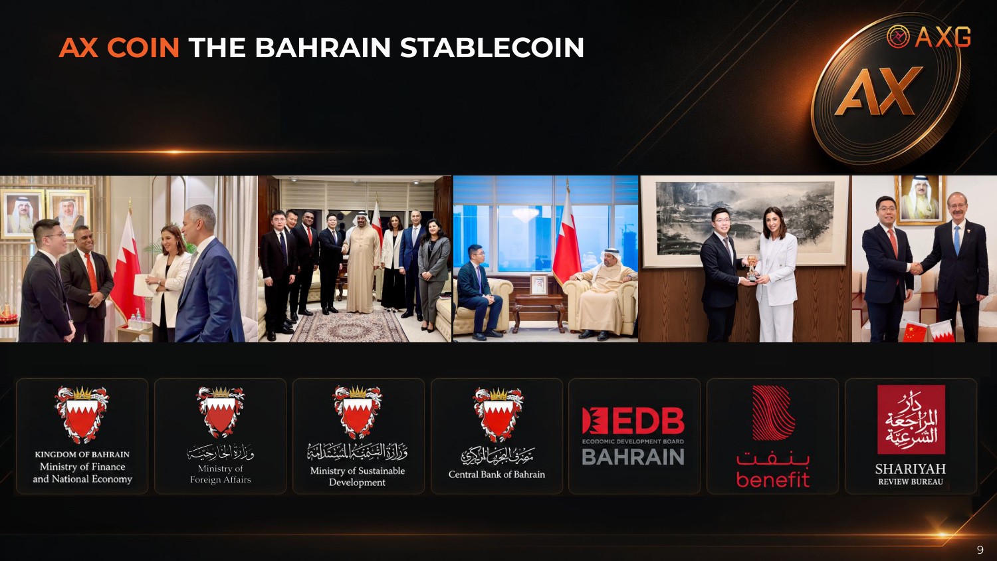
9 AX COIN THE BAHRAIN STABLECOIN

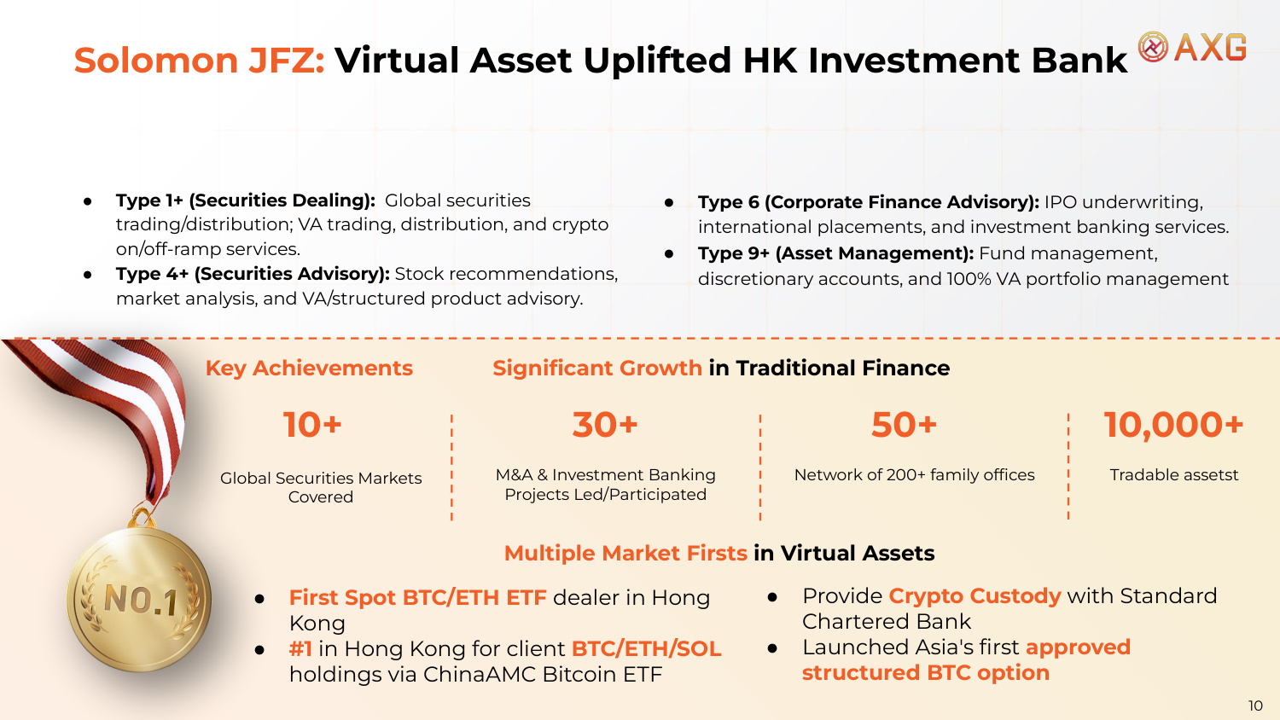
● Type 1+ (Securities Dealing): Global securities trading/distribution; VA trading, distribution, and crypto on/off-ramp services. ● Type 4+ (Securities Advisory): Stock recommendations, market analysis, and VA/structured product advisory. ● Type 6 (Corporate Finance Advisory): IPO underwriting, international placements, and investment banking services. ● Type 9+ (Asset Management): Fund management, discretionary accounts, and 100% VA portfolio management Key Achievements ● First Spot BTC/ETH ETF dealer in Hong Kong ● #1 in Hong Kong for client BTC/ETH/SOL holdings via ChinaAMC Bitcoin ETF 10+ Global Securities Markets Covered 10,000+ Tradable assetst Network of 200+ family offices 50+ M&A & Investment Banking Projects Led/Participated 30+ ● Provide Crypto Custody with Standard Chartered Bank ● Launched Asia's first approved structured BTC option Multiple Market Firsts in Virtual Assets Significant Growth in Traditional Finance Solomon JFZ: Virtual Asset Uplifted HK Investment Bank 10

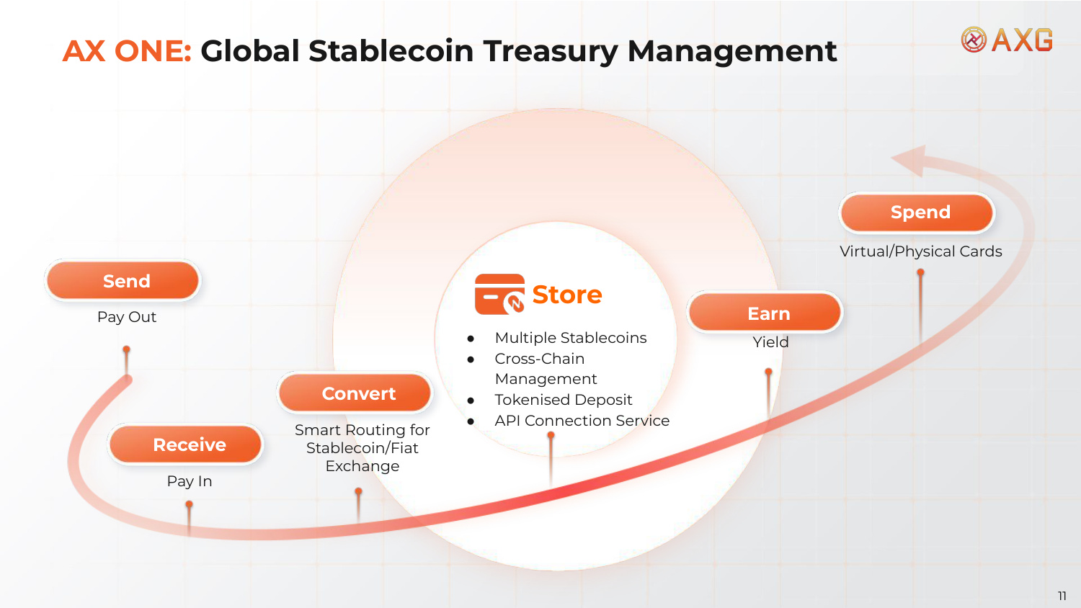
Receive Pay In Pay Out Send Convert Smart Routing for Stablecoin/Fiat Exchange Store ● Multiple Stablecoins ● Cross-Chain Management ● Tokenised Deposit ● API Connection Service Earn Yield Spend Virtual/Physical Cards AX ONE: Global Stablecoin Treasury Management 11

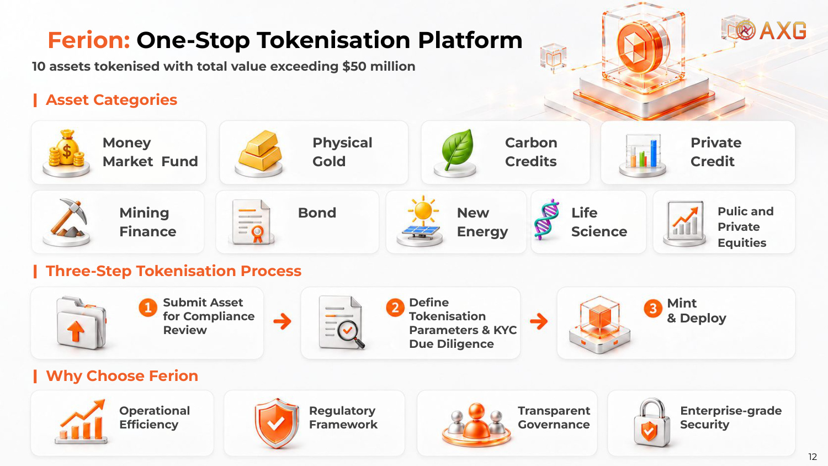
10 assets tokenised with total value exceeding $50 million Asset Categories Three-Step Tokenisation Process Why Choose Ferion Money Market Fund Physical Gold Carbon Credits Private Credit Mining Finance Bond New Energy Pulic and Private Equities Life Science Submit Asset for Compliance Review Define Tokenisation Parameters & KYC Due Diligence Mint & Deploy Operational Efficiency Regulatory Framework Transparent Governance Enterprise-grade Security Ferion: One-Stop Tokenisation Platform 12

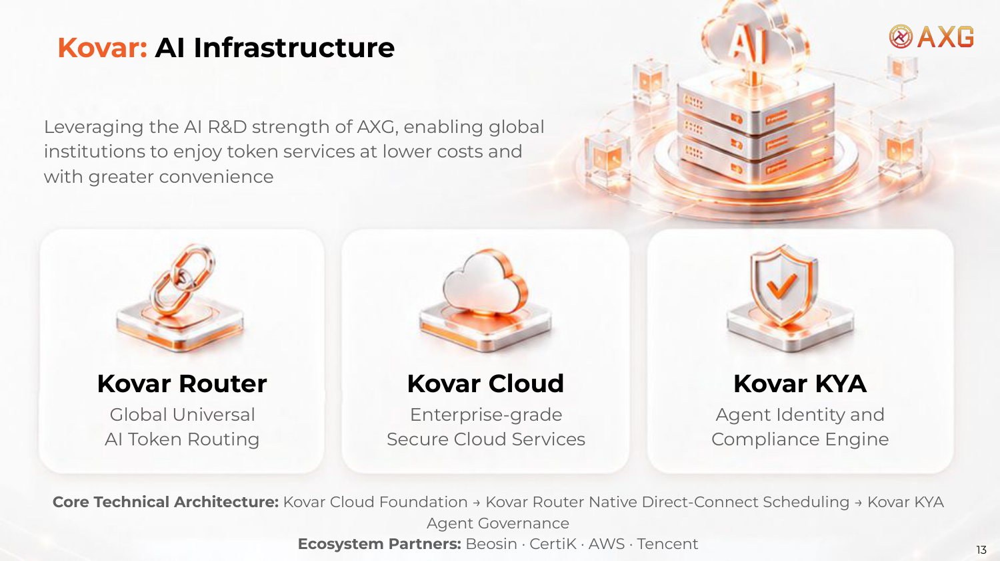
Leveraging the AI R&D strength of AXG, enabling global institutions to enjoy token services at lower costs and with greater convenience Kovar Router Global Universal AI Token Routing Kovar Cloud Enterprise-grade Secure Cloud Services Kovar KYA Agent Identity and Compliance Engine Core Technical Architecture: Kovar Cloud Foundation → Kovar Router Native Direct-Connect Scheduling → Kovar KYA Agent Governance Ecosystem Partners: Beosin · CertiK · AWS · Tencent Kovar: AI Infrastructure 13

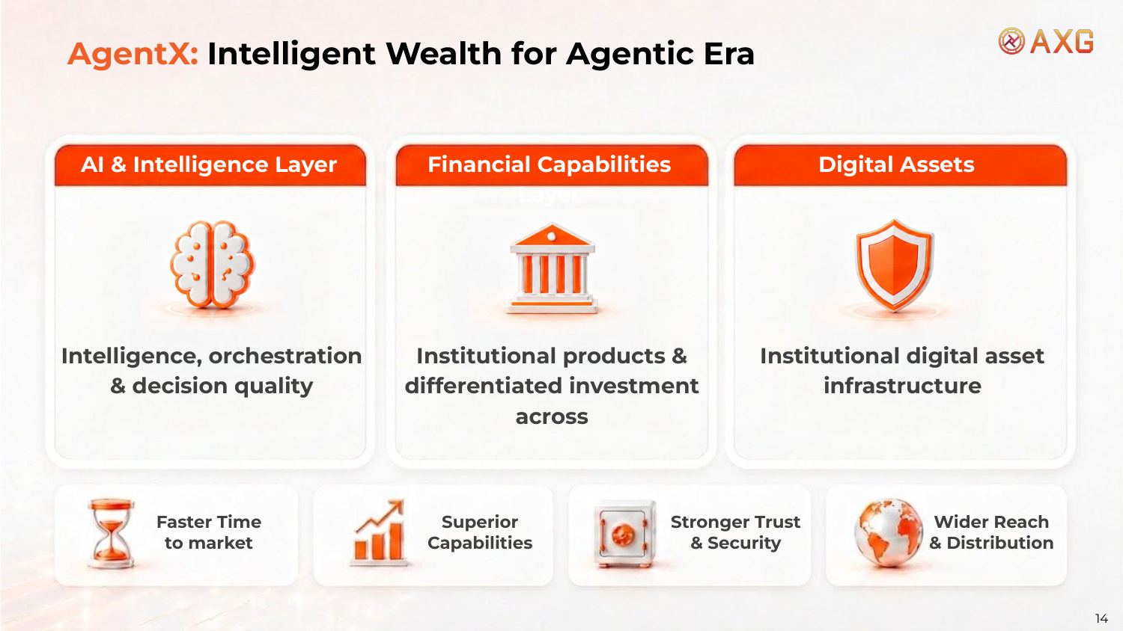
Intelligence, orchestration & decision quality Institutional products & differentiated investment across Institutional digital asset infrastructure Faster Time to market Superior Capabilities Stronger Trust & Security Wider Reach & Distribution AI & Intelligence Layer Financial Capabilities Layer Digital Assets AgentX: Intelligent Wealth for Agentic Era 14

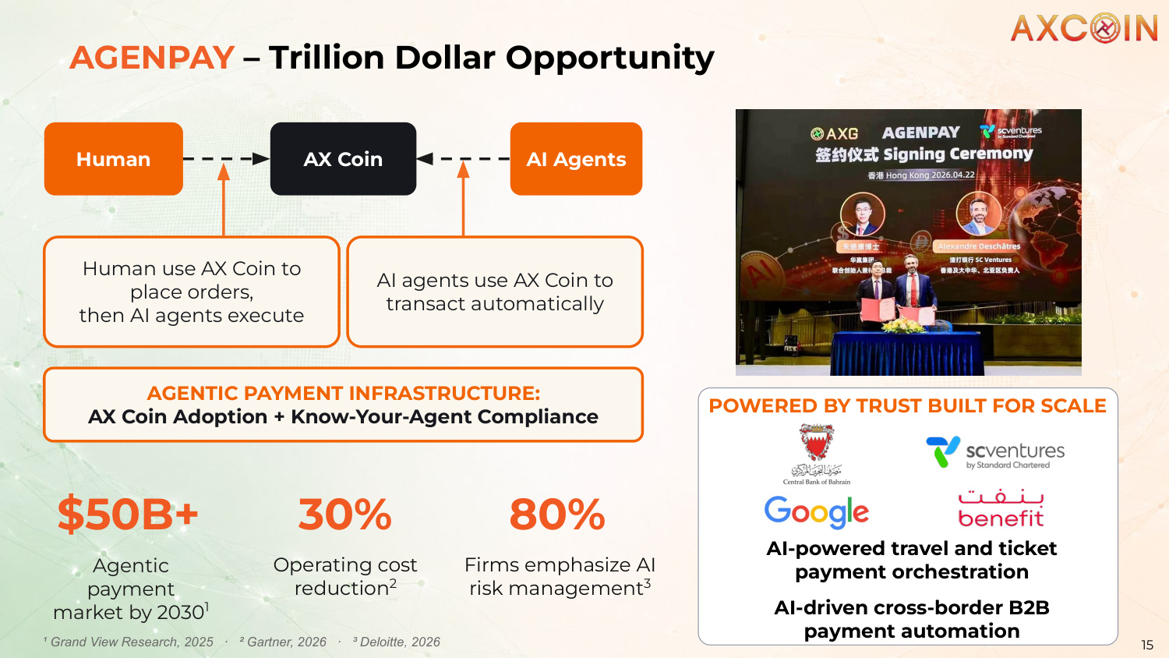
Human AX Coin AI Agents Human use AX Coin to place orders, then AI agents execute AI agents use AX Coin to transact automatically AGENTIC PAYMENT INFRASTRUCTURE: AX Coin Adoption + Know-Your-Agent Compliance AI-powered travel and ticket payment orchestration AI-driven cross-border B2B payment automation $50B+ Agentic payment market by 20301 30% Operating cost reduction2 80% Firms emphasize AI risk management3 ¹ Grand View Research, 2025 · ² Gartner, 2026 · ³ Deloitte, 2026 POWERED BY TRUST BUILT FOR SCALE 15 AGENPAY – Trillion Dollar Opportunity

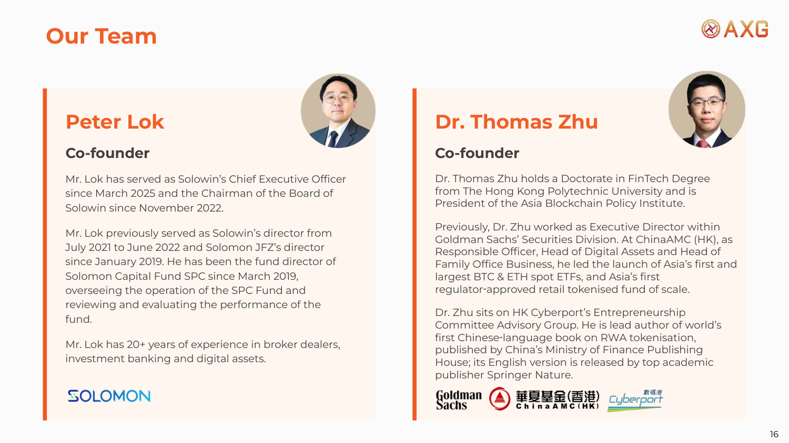
Our Team Peter Lok Co-founder Mr. Lok has served as Solowin's Chief Executive Officer since March 2025 and the Chairman of the Board of Solowin since November 2022. Mr. Lok previously served as Solowin's director from July 2021 to June 2022 and Solomon JFZ's director since January 2019. He has been the fund director of Solomon Capital Fund SPC since March 2019, overseeing the operation of the SPC Fund and reviewing and evaluating the performance of the fund. Mr. Lok has 20+ years of experience in broker dealers, investment banking and digital assets. Dr. Thomas Zhu Co-founder Dr. Thomas Zhu holds a Doctorate in FinTech Degree from The Hong Kong Polytechnic University and is President of the Asia Blockchain Policy Institute. Previously, Dr. Zhu worked as Executive Director within Goldman Sachs' Securities Division. At ChinaAMC (HK), as Responsible Officer, Head of Digital Assets and Head of Family Office Business, he led the launch of Asia's first and largest BTC & ETH spot ETFs, and Asia's first regulator-approved retail tokenised fund of scale. Dr. Zhu sits on HK Cyberport's Entrepreneurship Committee Advisory Group. He is lead author of world's first Chinese-language book on RWA tokenisation, published by China's Ministry of Finance Publishing House; its English version is released by top academic publisher Springer Nature. 16

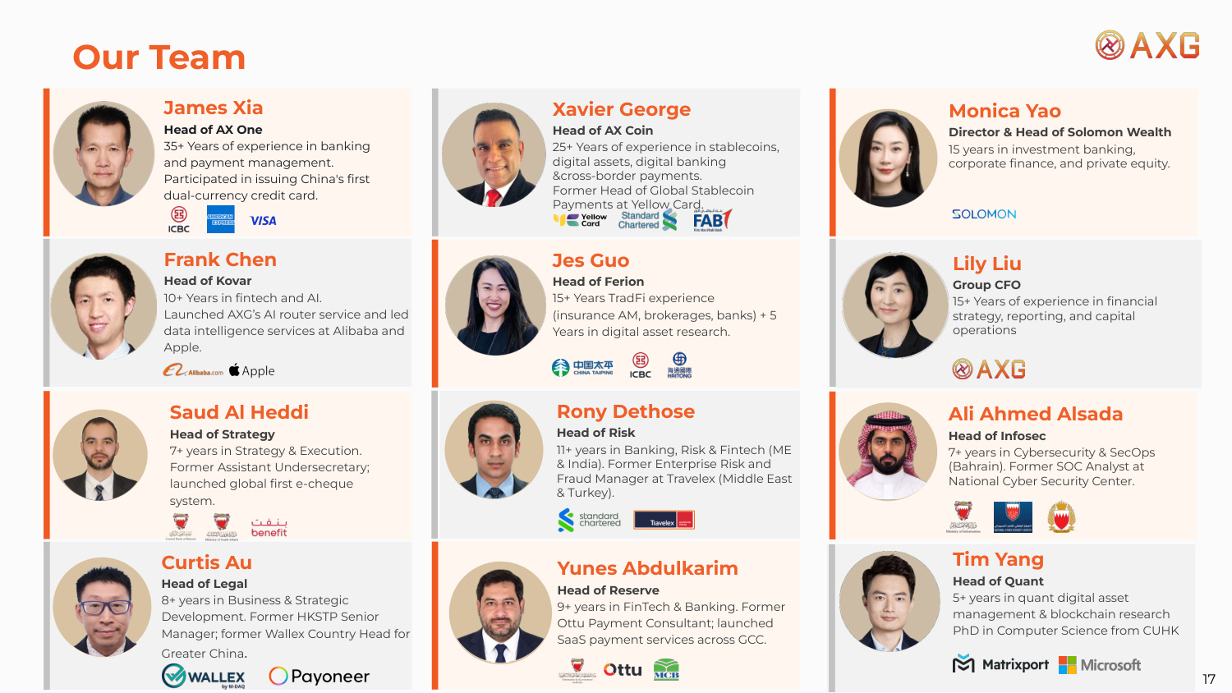
Our Team James Xia Head of AX One 35+ Years of experience in banking and payment management. Participated in issuing China's first dual-currency credit card. Frank Chen Head of Kovar 10+ Years in fintech and AI. Launched AXG's AI router service and led data intelligence services at Alibaba and Apple. Xavier George Head of AX Coin 25+ Years of experience in stablecoins, digital assets, digital banking &cross-border payments. Former Head of Global Stablecoin Payments at Yellow Card. Jes Guo Head of Ferion 15+ Years TradFi experience (insurance AM, brokerages, banks) + 5 Years in digital asset research. Tim Yang Head of Quant 5+ years in quant digital asset management & blockchain research PhD in Computer Science from CUHK Monica Yao Director & Head of Solomon Wealth 15 years in investment banking, corporate finance, and private equity. Curtis Au Head of Legal 8+ years in Business & Strategic Development. Former HKSTP Senior Manager; former Wallex Country Head for Greater China. 17 Yunes Abdulkarim Head of Reserve 9+ years in FinTech & Banking. Former Ottu Payment Consultant; launched SaaS payment services across GCC. Rony Dethose Head of Risk 11+ years in Banking, Risk & Fintech (ME & India). Former Enterprise Risk and Fraud Manager at Travelex (Middle East & Turkey). Ali Ahmed Alsada Head of Infosec 7+ years in Cybersecurity & SecOps (Bahrain). Former SOC Analyst at National Cyber Security Center. Lily Liu Group CFO 15+ Years of experience in financial strategy, reporting, and capital operations Saud Al Heddi Head of Strategy 7+ years in Strategy & Execution. Former Assistant Undersecretary; launched global first e-cheque system.

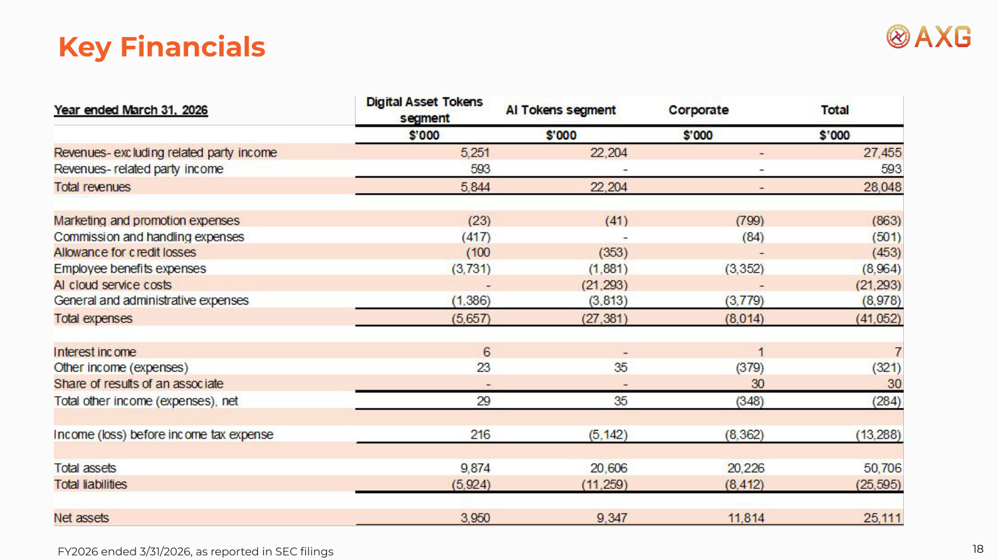
Key Financials FY2026 ended 3/31/2026, as reported in SEC filings 18

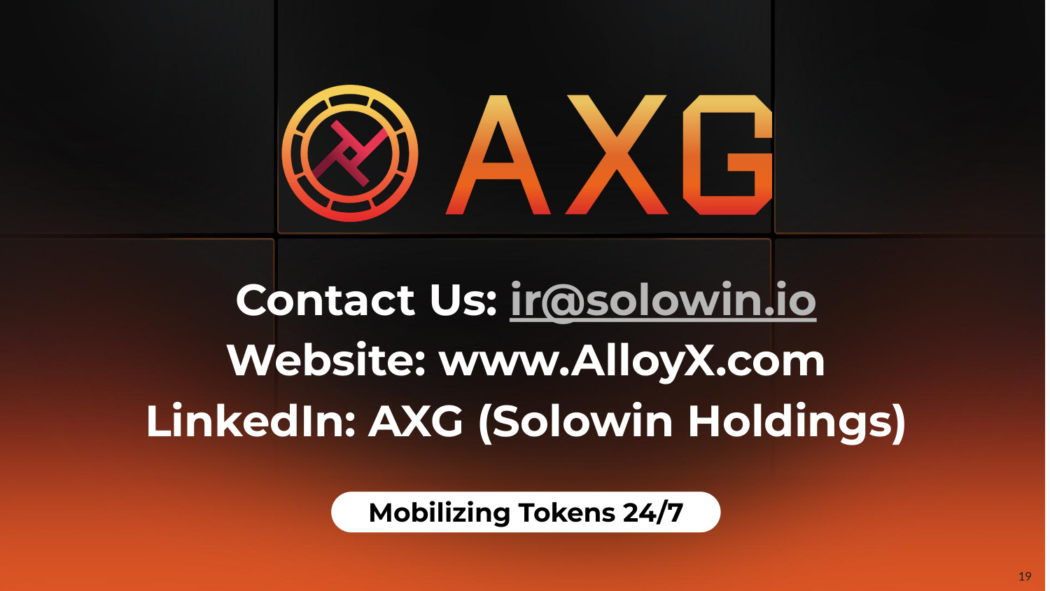
19 Contact Us: ir@solowin.io Website: www.AlloyX.com LinkedIn: AXG (Solowin Holdings) Mobilizing Tokens 24/7

